CSD 330 – Security Analytics

HW #3

Kabir Kanha Arora

Practical Exercises

- Run SVM classifier with 10-fold cross validation with at least three different kernels (no more than two can be polynomial kernels)
Answer:

- Linear Kernel (Polynomial with exponent = 1)
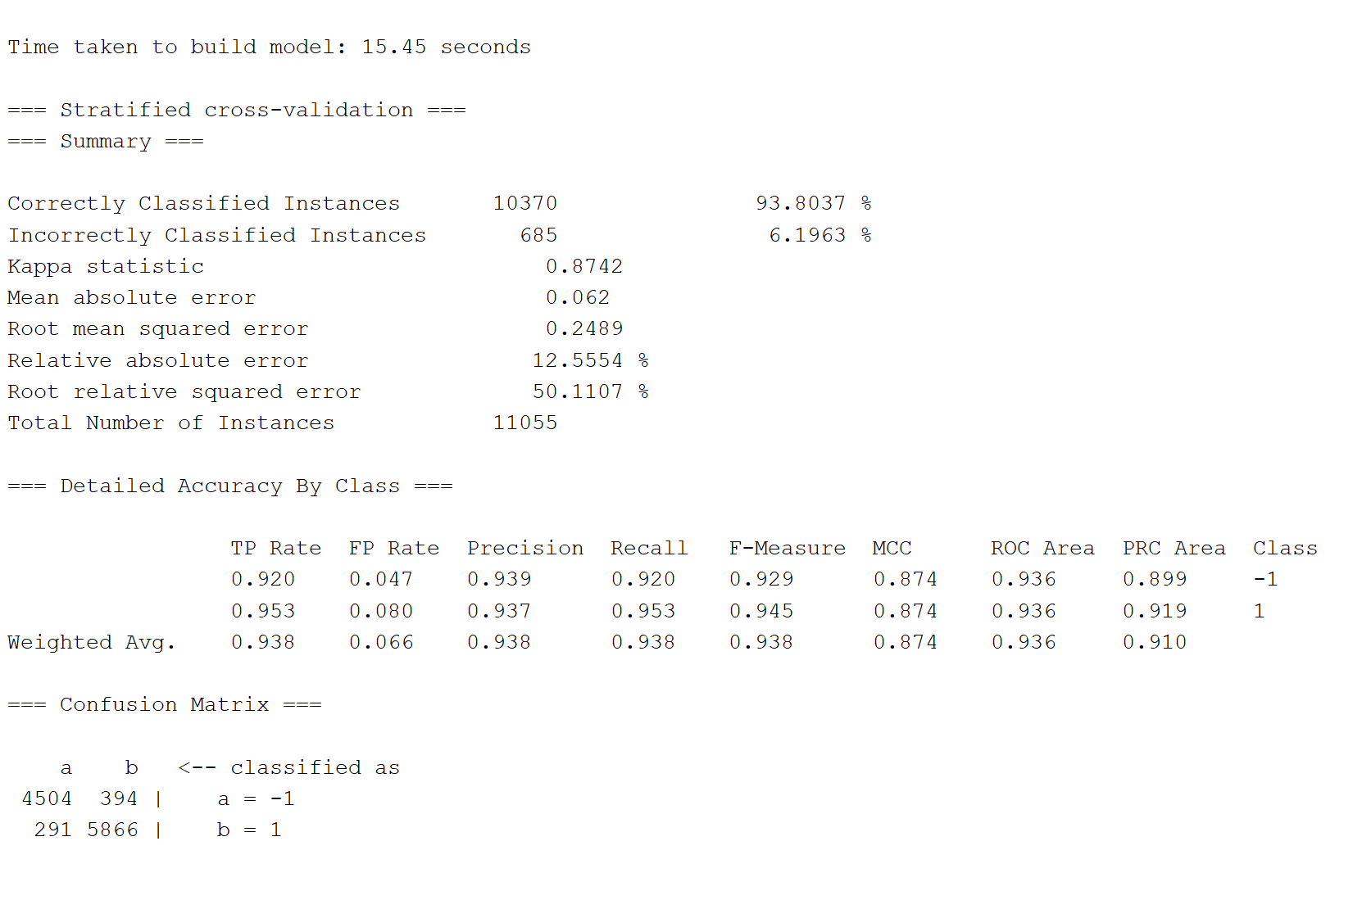

- RBFKernel
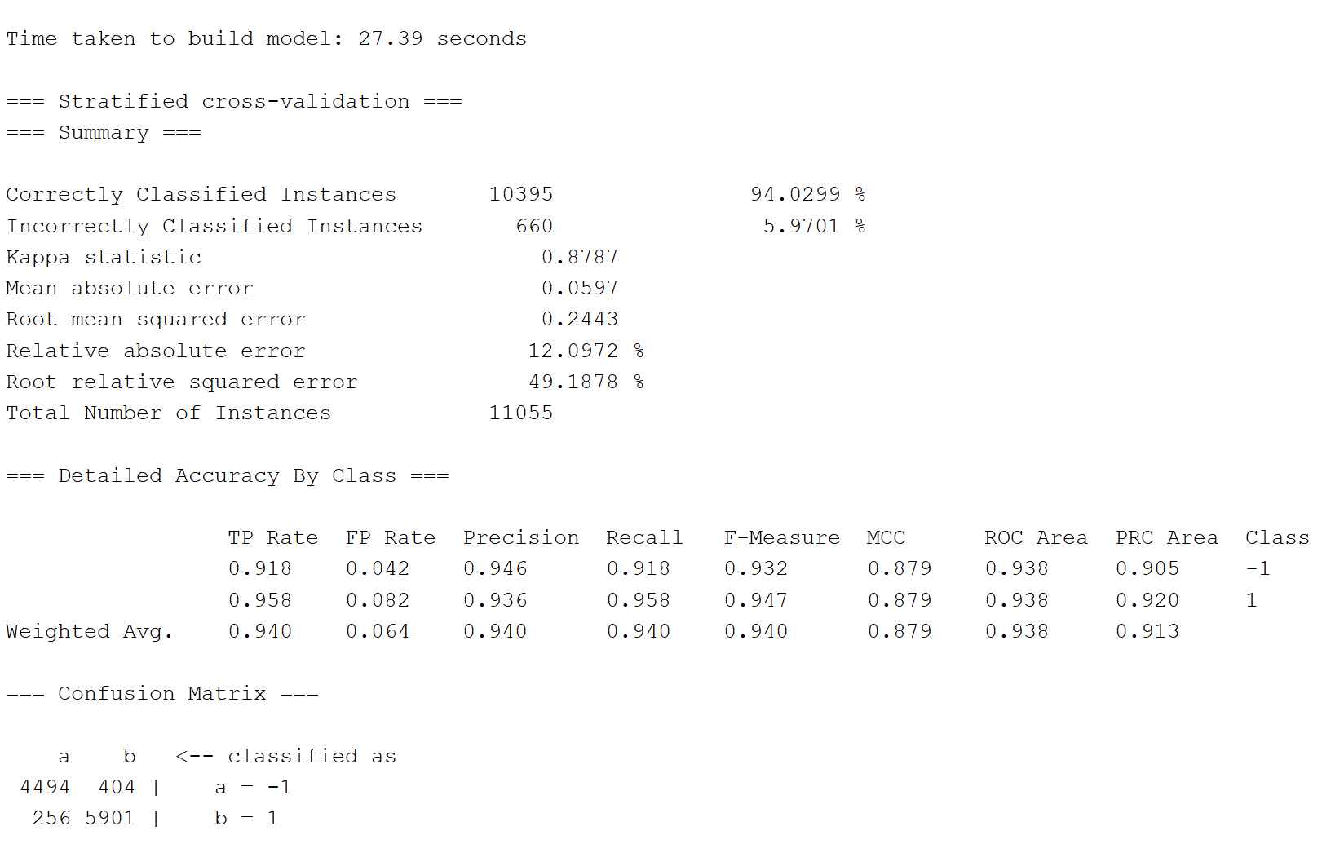
- Puk
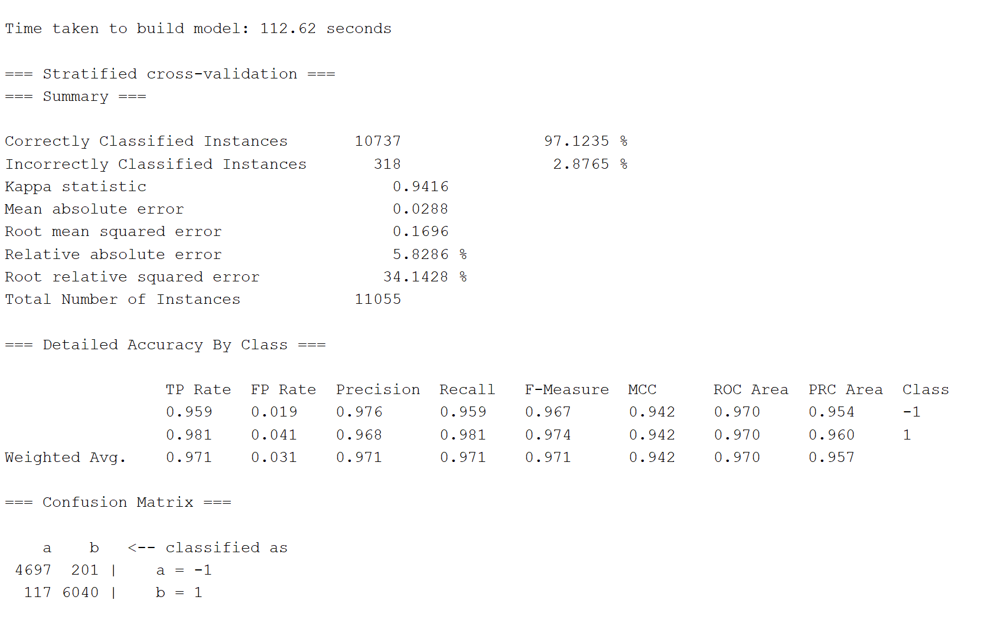
- So we see that the Puk kernel performs the best, it is also interesting to note that building this model took far more time that the other two.
- For more details, refer to the attached text files.
- On the same dataset, can you use the MLP classifier. If yes, try a 3-layer model. If not, explain why you can’t use it.
Answer:
Yes, Weka has the option of using a MultilayerPerceptron for classification.
I chose 46 neurons for the input layer since there are 46 features, 2 neurons for the output layer, since there are two classes we need to classify into, and chose the number of hidden layer neurons as 24 according to the formula Mean of input layer and output layer. I referred to the given link for help.
https://stats.stackexchange.com/questions/181/how-to-choose-the-number-of-hidden-layers-and-nodes-in-a-feedforward-neural-netw
Refer to txt file for more details.
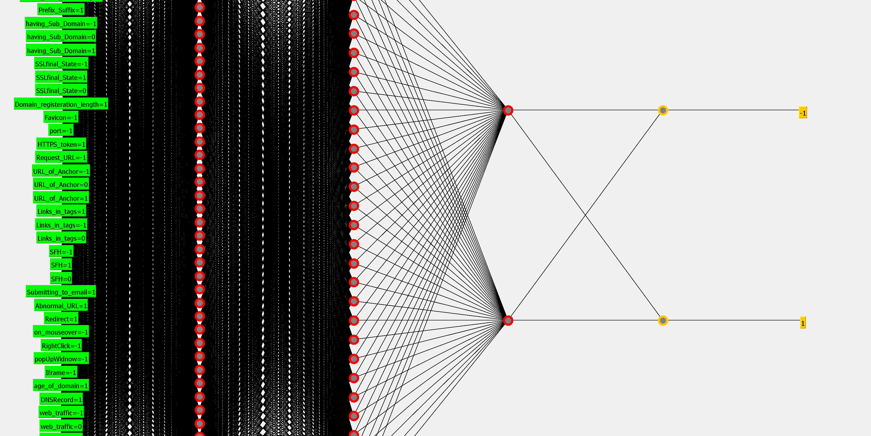
(The entire visualisation could not fit in one screenshot)
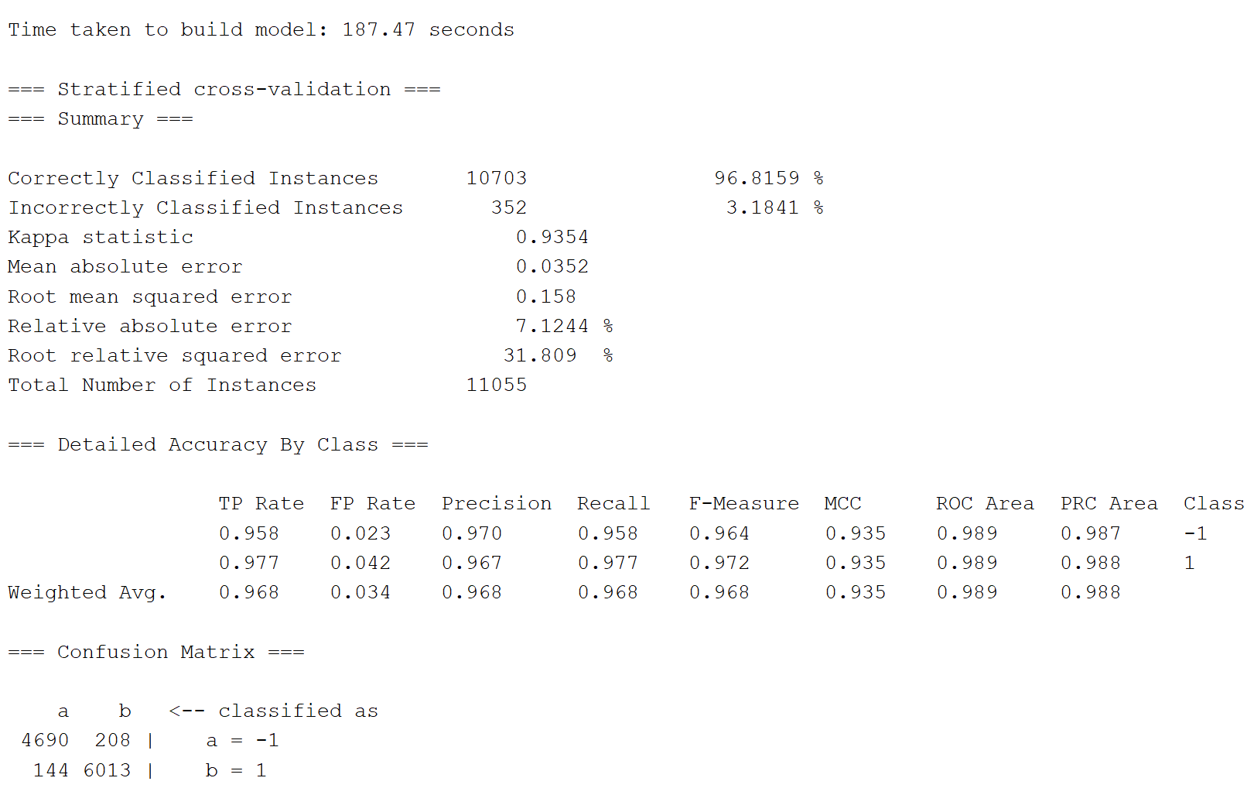
- Download and install LIBOL for online learning and try different online learning algorithms including: AROW, Passive Aggressive and Confidence Weighted algorithm (if available). It will be easier to install the software if you install a Git client first. Try controlling the number of iterations to 10, 100, 1000 (compare the results). http://libol.stevenhoi.org/LIBOL manual.pdf

Answer: Refer to attached text files

- Try Adaboost with SVM as the base classifier and compare the results with those in item 1 above.
Answer:
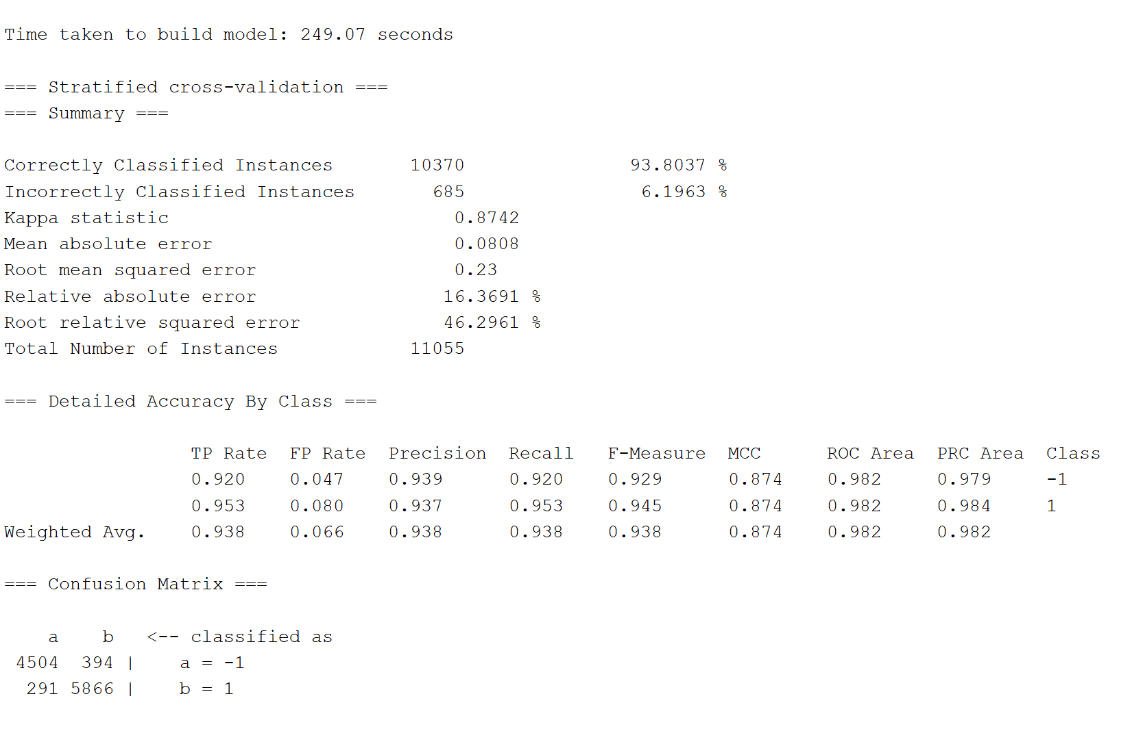
The first comparison right off the bat is that AdaBoost takes ages to build the model. While the other models in Q1 took negligible time, AdaBoost took a good 20 minutes to do the same. It gives results very similar to SVM with linear kernel, and worse than that with RBF and Puk. Refer to txt file for more details.

